**APT3020B Group Assignment: Developing a Rule-Based Matchmaking System for a Dating Application**

By: Alex Njagi (669524), Caroline Oriama (669257), Cynthia Yator (668184) and Dorcas Mwihaki (664318)

**Part 1: System Overview and Design**

+ The purpose of a rule-based matchmaking system is to derive a list of values that match an intended input based on compatibility comparison. By going through the compatibility scores, the system provides an engaging and effective means of matching a user’s inputs to potential outputs stored in the system’s database.

+ Therefore, the purpose of this dating matchmaking system is to match a user to potential partners stored in the system based on various attributes, taking inspiration from the popular dating site, Tinder. These attributes include age, interests, location, sex, preferred relationship type, love language, personality, MBTI-personality type, religion and sexual orientation and each will be weighted differently according to scoring rules.

+ Speaking of which, some of the scoring rules that have been assigned to these attributes to guarantee a balanced compatibility margin are: similar religions, sexual orientations and preferred relationship types will carry a weight of 0.1, matching locations and MBTI-personality types will carry a weight of 0.15, age will carry a weight of 0.25 according to the calculated age range that allows a threshold of 20 years and similar interests across users will carry a weight of 0.5 to be multiplied by the Jaccard score of intersecting interests. All these scoring rules will be collectively analysed to determine the best matches for an intended user.

+ Finally, the main data structure that will house the systems methods and rules will be a *KnowledgeBase* class which will define the procedures to add, retrieve and delete profiles as well as the *Matchmaking* class which will implement matchmaking system logic using compatibility rules and weights to find optimal matches for a given profile. Pre-made user profiles will be stored in the form of dictionaries embedded in a list and will be analysed according to their attributes.

**Part 2: Implementation, Testing and Evaluation**

+ Below is a sample testing process to evaluate the matchmaking capabilities of this system and the output it returns:

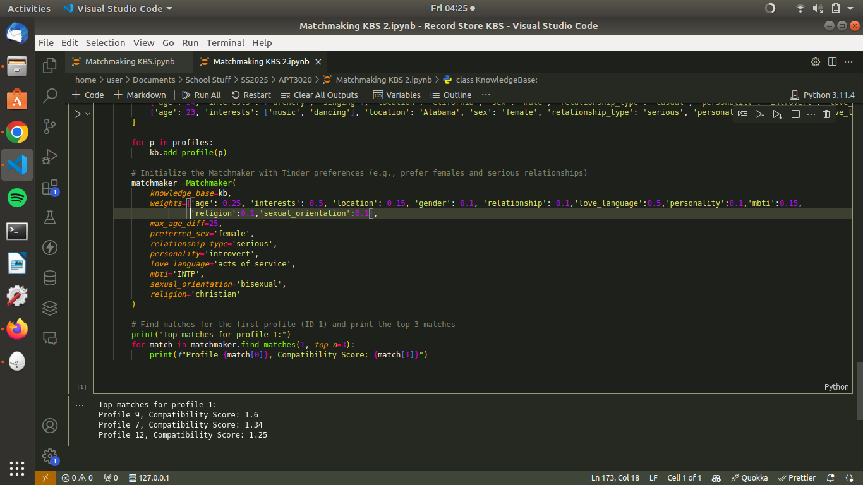

+ From the evaluation, the system returned three matches each with their calculated compatibility scores to the evaluation information, namely profiles 9, 7 and 12. The profiles stored in the system can be found below:

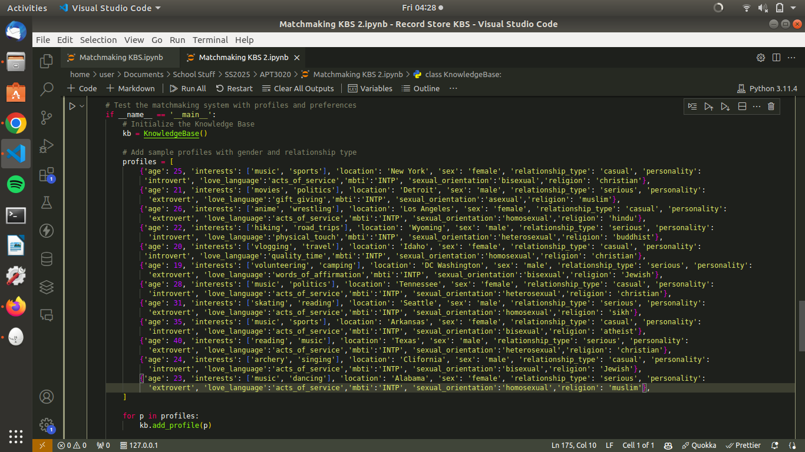

+ Therefore, in a similar vein to the system, we can analyse why the three profiles were chosen:

1. Profile 9: There was a strong alignment with love language, personality, MBTI, sexual orientation, and interests hence why despite the "casual" relationship type and different religion hurting the score, it was still ranked high.
2. Profile 7: There was a very strong match on personality, love language, MBTI, religion, and interests however the relationship type, sexual orientation and location attributes presented a mismatch, which though not great enough to outright diminish the score, put this profile a little lower on the totem pole.
3. Profile 12: There was a very strong alignment in terms of love language, MBTI, interests and especially relationship type. However, notable mismatches in sexual orientation, personality, and religion hurt the score, but it still ranked high.

+ Therefore, it is evident that this matchmaking system is effective in predicting optimal dating matches similar to ‘Tinder’. However, some limitations and possible improvements that could be made include the ability to take gender preferences into account in matchmaking, adding a GUI or web interface for user interaction and allowing users to customize weightings for different attributes. Besides that, we believe our system is an effective and well-functioning dating application prototype.